**ANALYSING THE PERFORMANCE AND EFFICIENCY OF THE RADISSON HOTELS USING DATA VISUALIZATION TECHNIQUES**

1. **.INTRODUCTION:**

**1.1 OVERVIEW:**

The hotel industry is a broad category of businesses that provide lodging services for travellers and tourists. This can include a wide range of establishments, from luxury resorts to budget-friendly motels, as well as extended stay hotels, boutique hotels, and more. Hotels can be found in nearly every corner of the world, and are often a major component of the tourism and travel industry in a given area.

Radisson owns multiple five-star hotels across India. They have been in the hospitality industry for the past 100 years. Due to strategic moves from other competitors and ineffective decision-making in management, Radisson is losing its market share and revenue in the luxury/business hotels category. As a strategic move, the managing director of Radisson wanted to incorporate Business and Data Intelligence in order to regain their market share and revenue. Our task is to create an analytics dashboard & story to provide them insights to make better business decisions.

* 1. **PURPOSE:**

The business requirements for analyzing the performance and efficiency of Radisson Hotels include identifying KPIs, comparing performance across different hotels, identifying patterns and trends over time, identifying affecting factors, creating interactive dashboards and reports, identifying areas for improvement, making datadriven decisions, comparing to industry average and creating forecasting models for future performance. The ultimate goal is to gain insights and improve performance through data visualization techniques.

A literature survey is a method of researching existing literature and studies related to a specific topic. In the context of analyzing the performance and efficiency of Radisson Hotels, a literature survey would involve reviewing studies and articles that have been published on the topic of hotel performance and efficiency, as well as studies specific to Radisson Hotels.The literature survey would include sources such as academic journals, industry reports, and online articles. It would aim to identify key performance indicators (KPIs) and metrics that are commonly used to measure hotel performance and efficiency, as well as any best practices or strategies that have been identified for improving performance.The literature survey would also explore any existing research on Radisson Hotels specifically, and would aim to identify any unique challenges or opportunities that the hotel chain faces in terms of performance

**Problem Definition & Design Thinking:**

**EMPATHY MAP:**

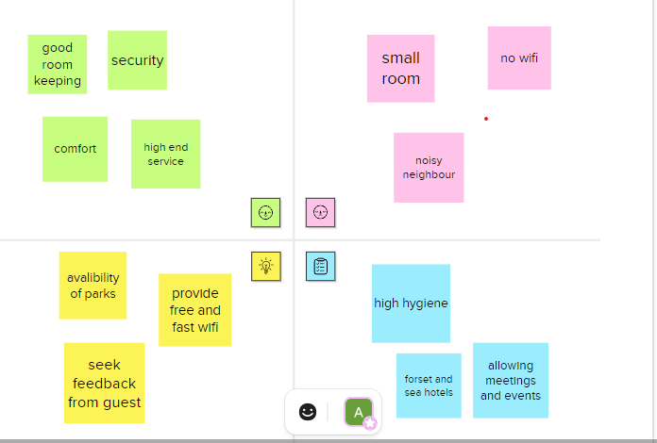

**2.2Ideation & Brainstoming Map:**

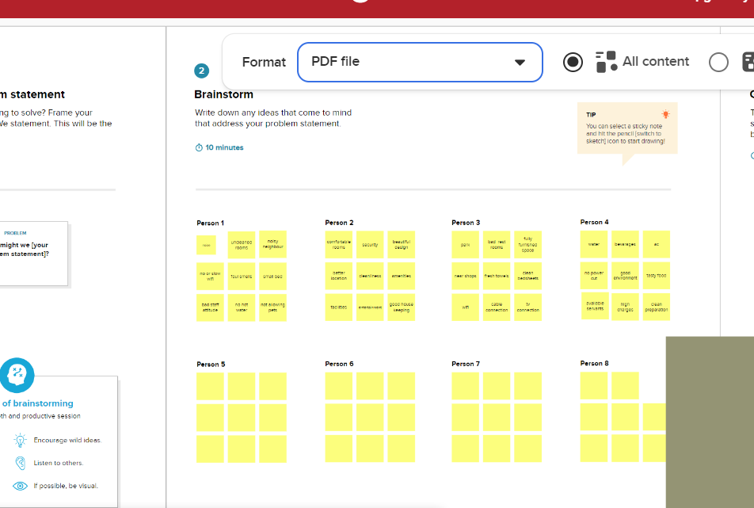

**RESULT:**

|  |  |
| --- | --- |
| Object name | Fields in the objects |
| Date | |  |  | | --- | --- | | Field label | Data type | | Date | number | | Mmm yy | number | |
| Hotels | |  |  | | --- | --- | | Property id | text | | Property name | text | | category | text | | city |  | |
| rooms | |  |  | | --- | --- | | Room id | number | | Roomclass | text | |

**Trail head profile public URL:**

**Team Leader :** https://trailblazer.me/id/devika012

**Team member 1 :**https://trailblazer.me/id/benosp10

**Team member 2 :** https://trailblazer.me/id/crani28

**Team member 3 :** https://trailblazer.me/id/dkripads012

**3.2.ACTIVITY SCREENSHOT:**

**REVENUE SPLIT BY CITY:**

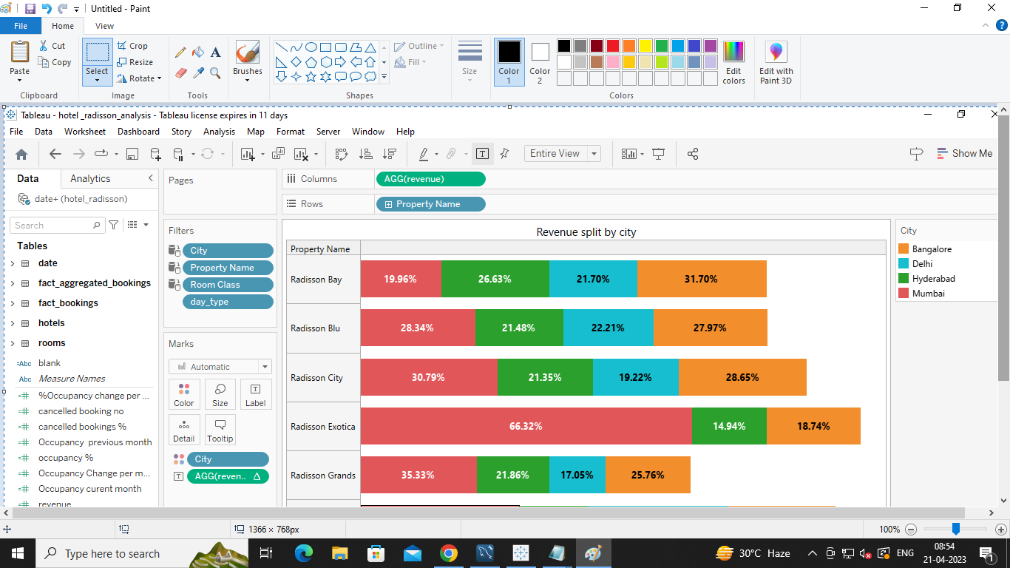

**OCCUPANCY SPLIT BY CITY:**

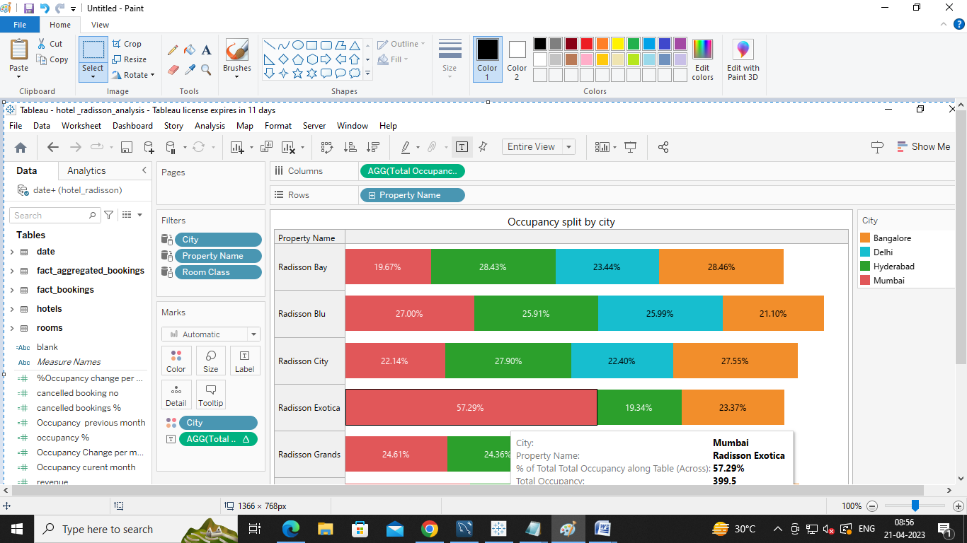

**OCCUPANCY BY DAY TYPE:**

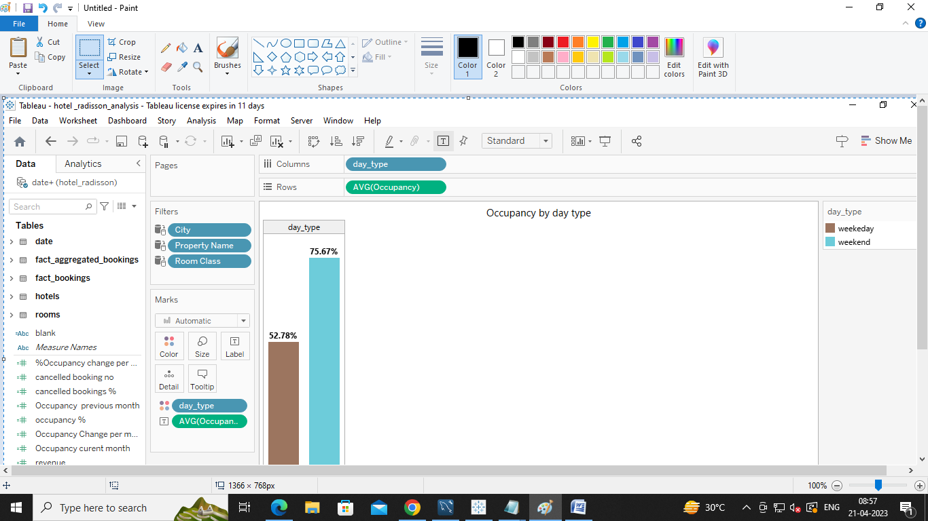

**REVENUE BY ROOM CLASS:**

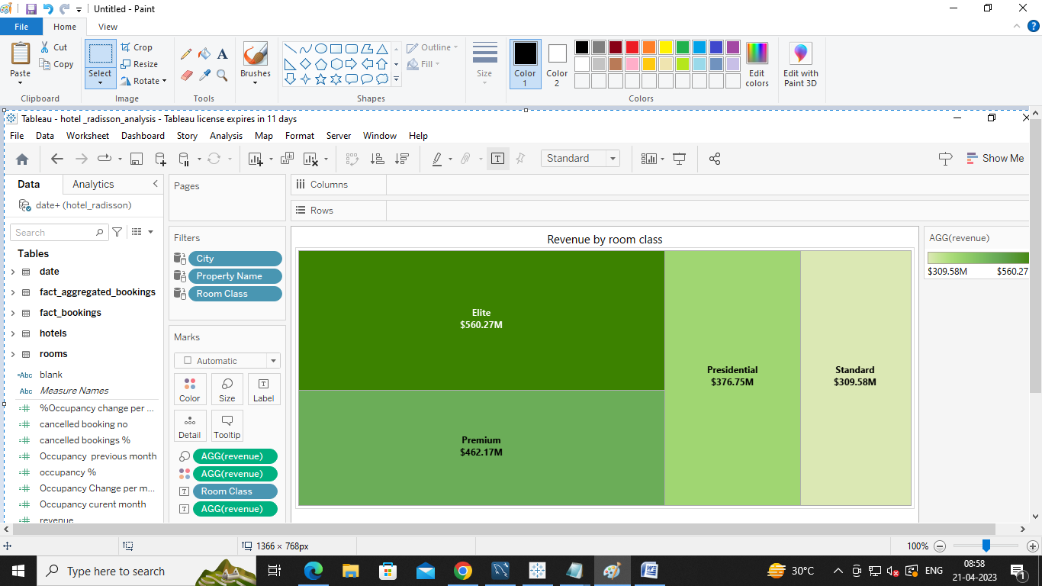

**BOOKING % BY PLATFORM:**

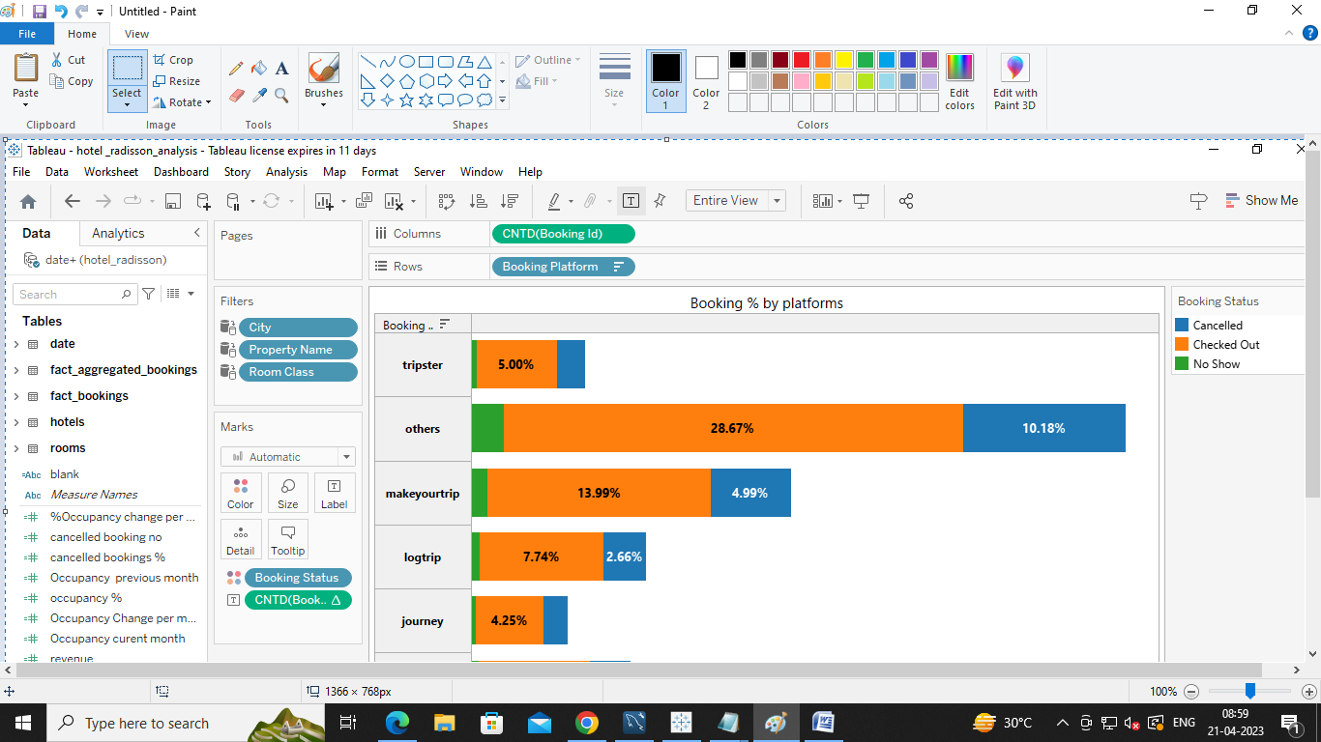

**PROPERTY BY KEY METRICS:**

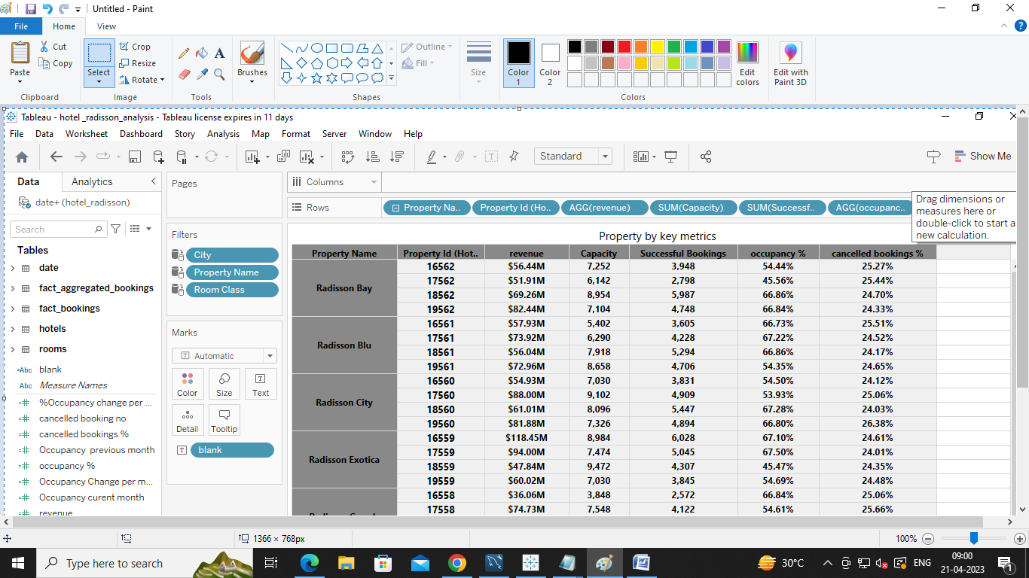

**REVENUE CONTRIBUTION % BY CATEGORY:**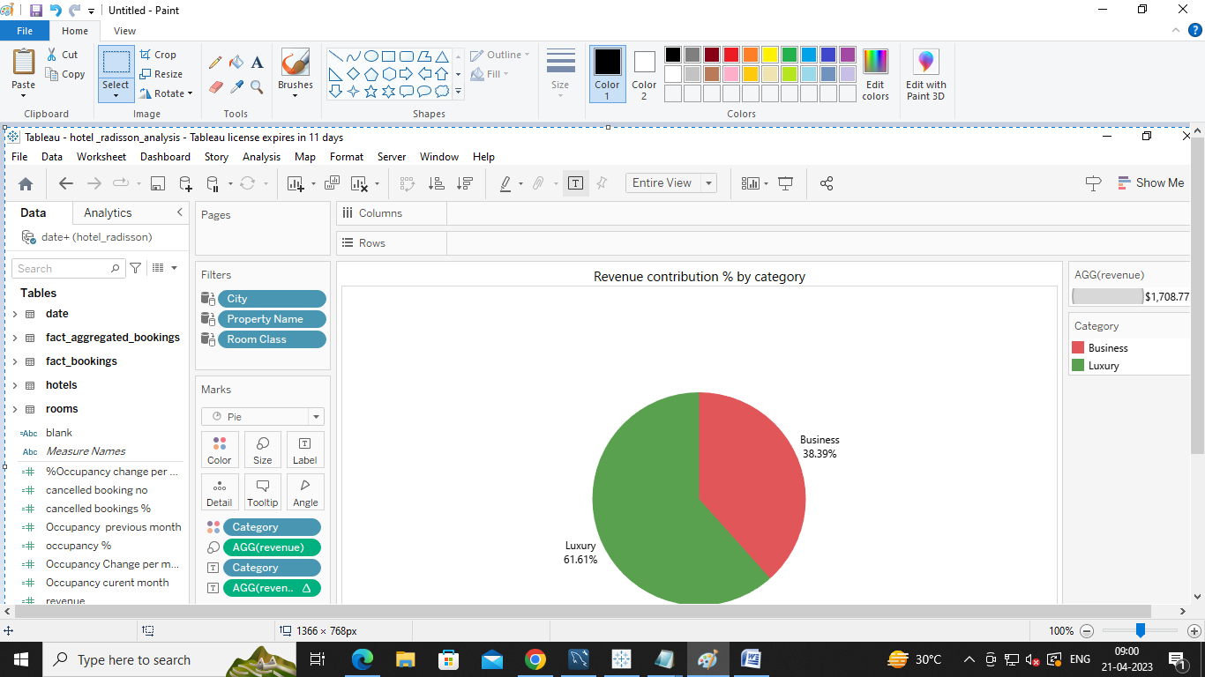

**SUCCESSFUL BOOKINGS BY CITY:**

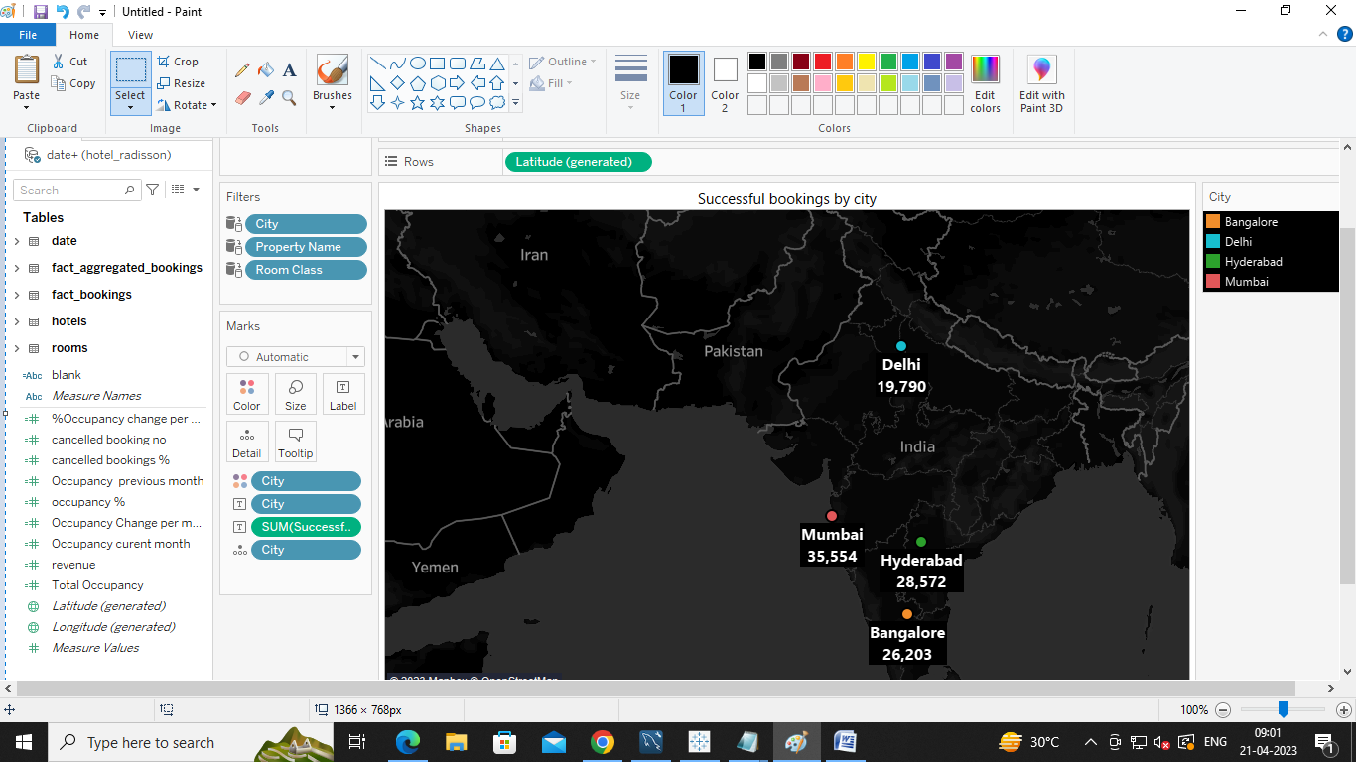

**SUCCESSFULBOOKING BY DATE WISE:**

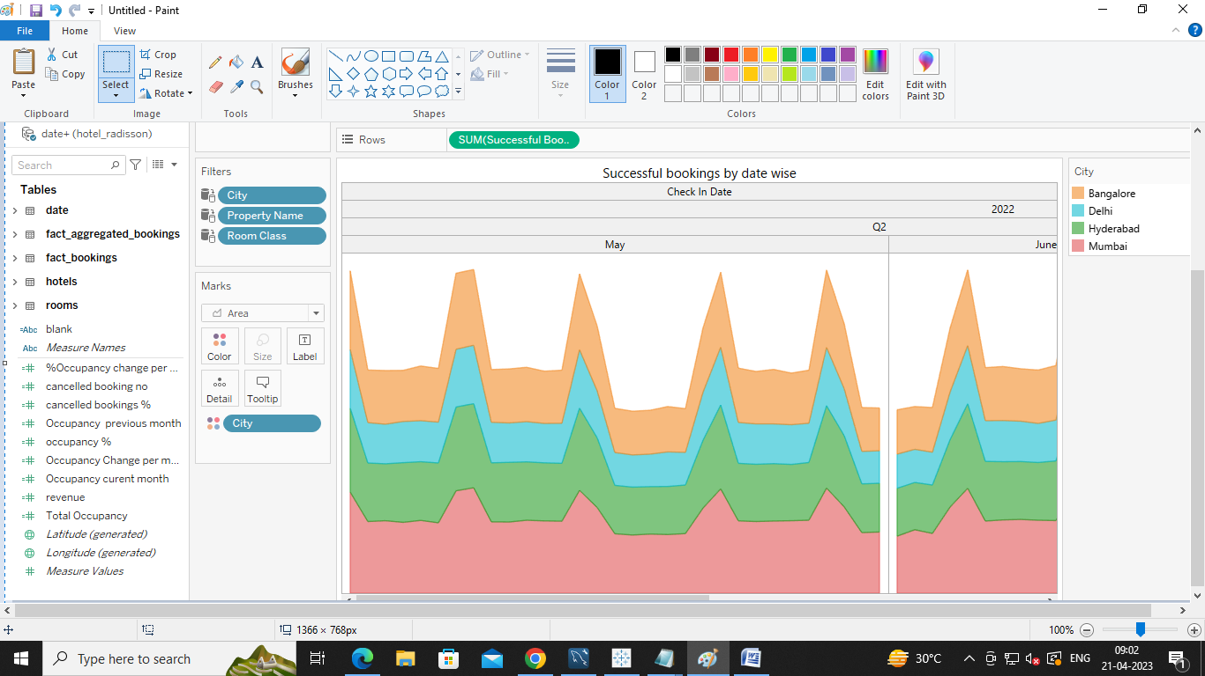

**TOTAL REVENUE FOR THE HOTELS:**

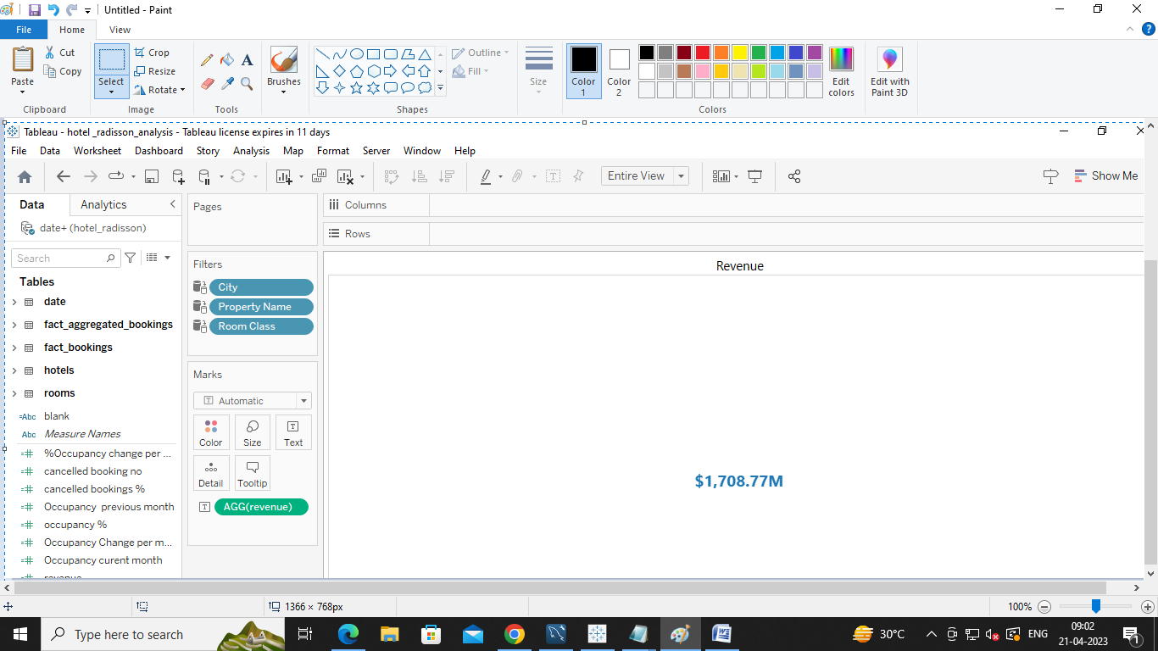

**TOTAL SUCCESSFUL BOOKINGS:**

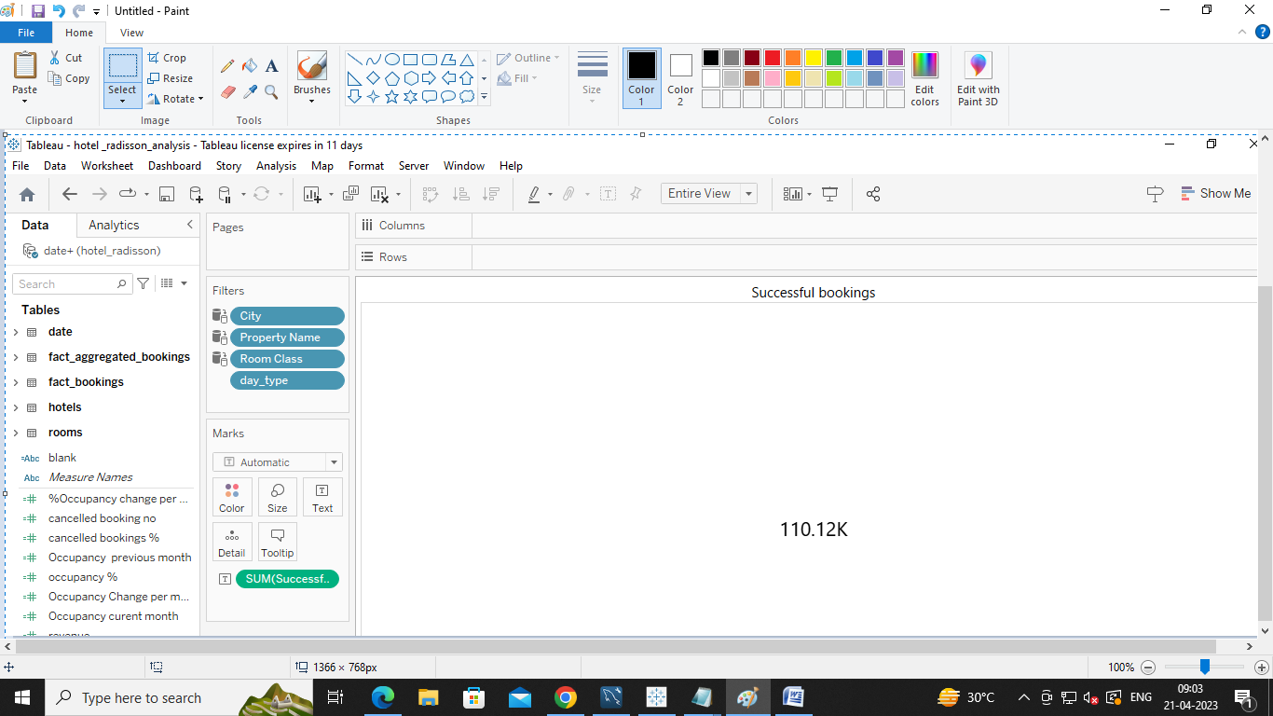

**OCCUPANCY IN %:**

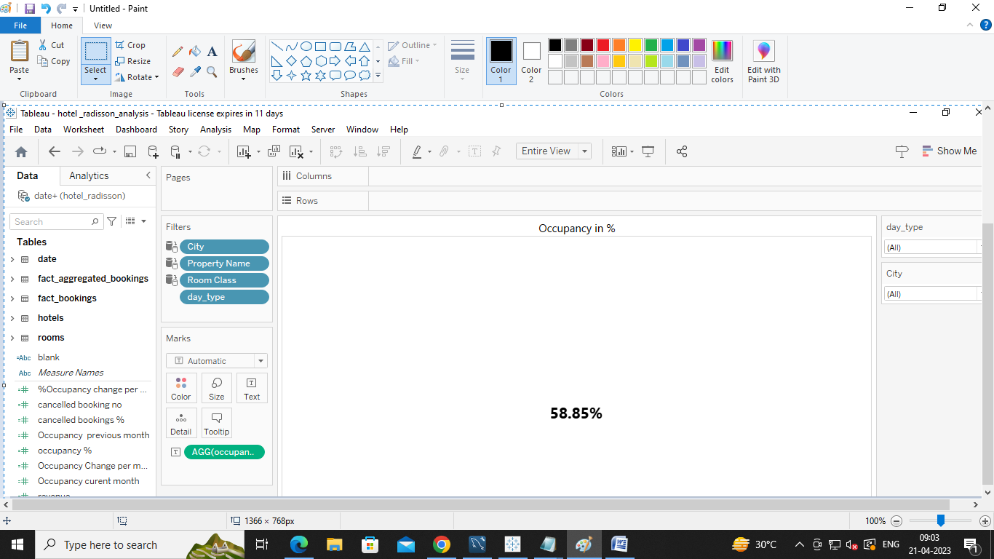

**PROJECT REPORT TEMPLATE**

**5.ADVANTAGES & DISATVANTAGES**

**ADVANTAGES:**

The strengths of Radisson Hotels looks at the key aspects of its business which gives it competitive advantage in the market. Some important factors in a brand's strengths include its financial position, experienced workforce, product uniqueness & intangible assets like brand value. Below are the Strengths in the SWOT Analysis of Radisson Hotels :

1. Top notch service and excellent customer service

2. Global presence –420+ hotels globally in over 75 countries  
3. Goodwill from Employees and customers

4. They offer really go deals and promotional offers hence attracting more customers

5. Parent group adds to brand value

6. High Brand Recall

The opportunities for any brand can include areas of improvement to increase its business. A brand's opportunities can lie in geographic expansion, product improvements, better communication etc. Following are the opportunities in Radisson Hotels SWOT Analysis:

1. Using current economic scenario to increase clientele through special packages  
2. Expansion of the global tourism market  
3. Travellers are looking for novel destinations

**DISADVANTAGES:**

The weaknesses of a brand are certain aspects of its business which are it can improve to increase its position further. Certain weaknesses can be defined as attributes which the company is lacking or in which the competitors are better. Here are the weaknesses in the Radisson Hotels SWOT Analysis:

1. The brand name comes with a perception of being expensive

2. Current economic status is bound to take a toll on spending power

3. Still trying to establish itself in the emerging economies

The threats for any business can be factors which can negatively impact its business. Some factors like increased competitor activity, changing government policies, alternate products or services etc. can be threats. The threats in the SWOT Analysis of Radisson Hotels are as mentioned:

1. Shift from 4-5 star hotels to lower ones  
2. Terrorism events affects the tourism  
3. Huge number of strong competitors

**6.APPLICATION:**

**Operating model**  
Developing the new operating model needed to support a single global Radisson Hotels brand including a new Digital organization to support the modeL.

**Technology**  
Defining an integrated AdTech and MarTech stack to support new capabilities in ad verification, ad serving, bidding, demand-side platforms, data management, data visualization, and more.

**Market analysis**  
Offering in-depth analysis of Radisson Hotels’ principal markets, local media partners, competitor landscape, and individual customer behavior.

**Forecasting and cost recovery**  
Defining a global forecasting and cost recovery model, supporting the development and planning of Radisson Hotels’ growth agenda

**Advanced analytics**  
Embedding advanced analytical capabilities to support data-driven attribution and propensity models and optimize digital campaign performance

**7.CONCLUSION:**

We have submitted Revenue split by city, Occupancy split by city , Occupancy by day type , Revenue by room class , Booking % by platforms , Property by key metrics , Revenue contribution %by category , successful bookings by city , successful bookings by date wise , Total Revenue for the hotels , Total successful bookings , Occupancy in %.